Application Design: Community Event Planning and Management System

Samita Tamang
Department of Computer Science, Monroe University
CS700-151HY - Special Projects in Computer Science
Professor Oluwole Omole-Ohonsi
7/12/2025

Application Design: Community Event Planning and Management System

System Screens
# | Screen Name | Primary Roles | What It Displays & Does
1 | Landing / Home | All | Public welcome page with brief platform overview and a “Browse Events” call-to-action.
2 | Login & Register | All | Secure sign-in / sign-up forms (email, password, role pick) plus “Forgot Password”.
3 | User Dashboard | Community Member, Volunteer, Sponsor | Personalized snapshot: upcoming events, tasks, sponsorships, unread notifications.
4 | Event Catalog | Community Member, Volunteer, Public | Searchable list of upcoming events with filters (date, location) and “View Details”.
5 | Event Details | Community Member, Volunteer, Public | Full event info, organizer profile, task list, feedback summary, “Register” & “Volunteer” buttons.
6 | Event Registration Form | Community Member | Simple form to confirm attendance → returns confirmation notice.
7 | My Registrations | Community Member | Table of events the user joined with status (confirmed / canceled) and “Cancel” option.
8 | Feedback Form | Community Member | Rating (1-5) + comment box; available only after attending.
9 | Organizer Dashboard | Organizer | At-a-glance metrics: upcoming events, attendee counts, pending feedback.
10 | Create Event | Organizer | Multi-step wizard for title, date, location, tasks, sponsor needs.
11 | Edit Event | Organizer | Same fields as Create, pre-filled for updates.
12 | Attendee List | Organizer | Real-time roster of registered users with export and email options.
13 | Feedback Viewer | Organizer | Filterable list of ratings & comments tied to an event.
14 | Volunteer Task Board | Volunteer | List of available tasks with “Sign Up” buttons; shows remaining slots.
15 | My Volunteer Schedule | Volunteer | Calendar / list view of tasks assigned, with reminders toggle.
16 | Update Availability | Volunteer | Simple form for date & time preferences; feeds assignment logic.
17 | Admin Event Approval | Admin | Queue of newly created events with Approve / Reject actions and comments.
18 | User Management | Admin | Searchable user table, block / edit controls, role assignment dropdown.
19 | System Logs & Reports | Admin | Audit log viewer plus high-level analytics (registrations, feedback trends).
20 | System Settings | Admin | Config panels for email templates, role permissions, security options.
21 | Sponsor Dashboard | Sponsor | Snapshot of active sponsorships, pending acknowledgments, impact reports.
22 | Sponsorship Offer Form | Sponsor | Input amount / resource type, choose target event(s), set visibility prefs.
23 | Sponsorship Acknowledgment | Sponsor | Thank-you message, certificate download, social-share buttons.
24 | Sponsorship Reports | Sponsor | Post-event summary: attendance, exposure metrics, organizer note.
25 | Notifications Center | All | List of unread / read alerts with quick links to related screens.
26 | Profile & Preferences | All | Edit personal info, change password, notification settings, delete account.

Screen Map
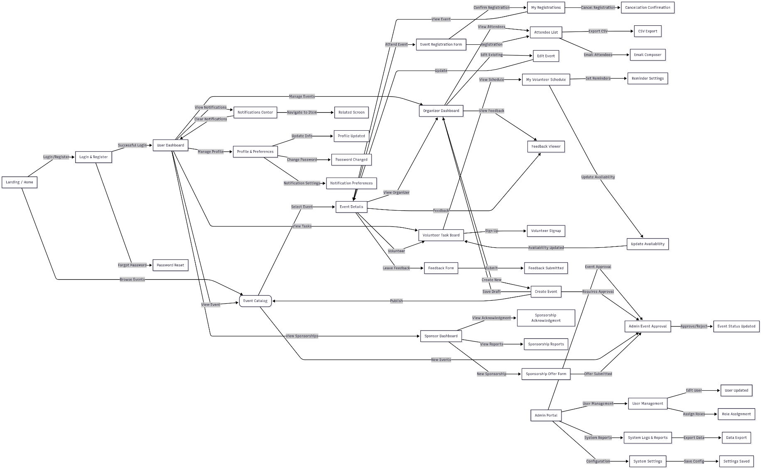

Screen Mockups
Landing/Home screen
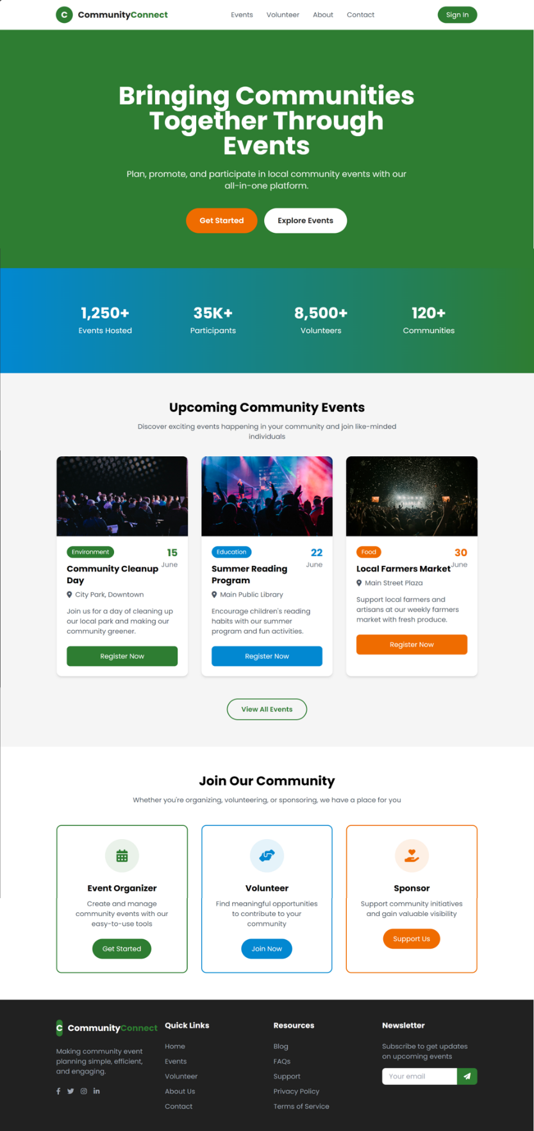
Sign in
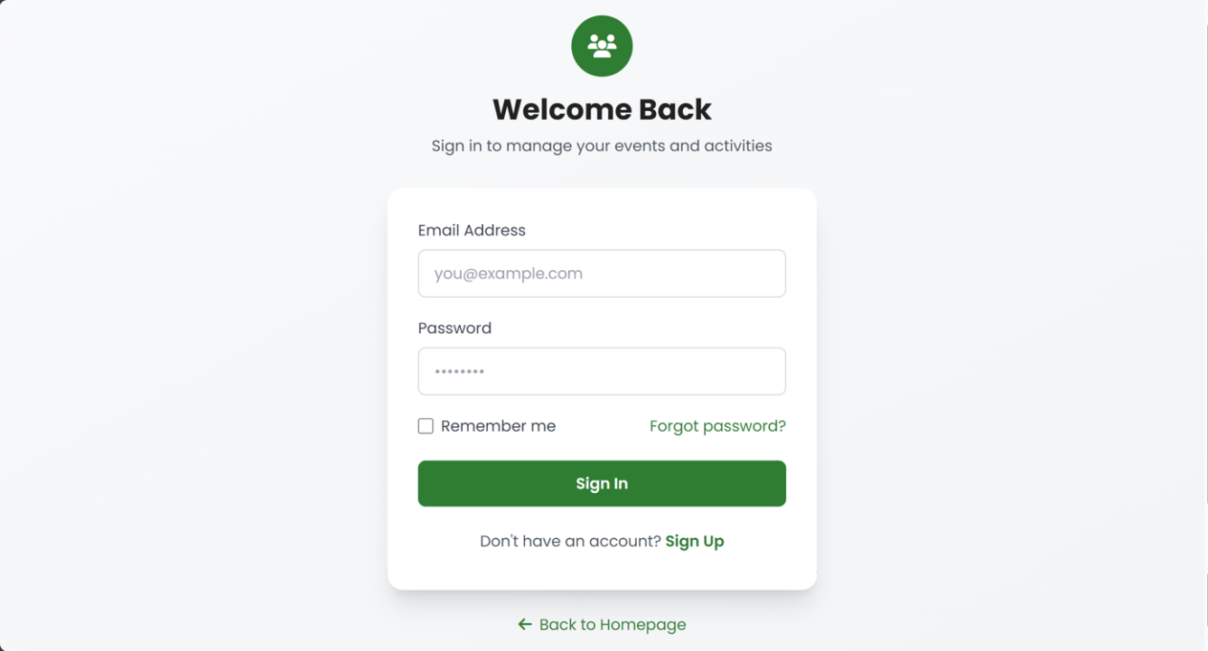
Signup
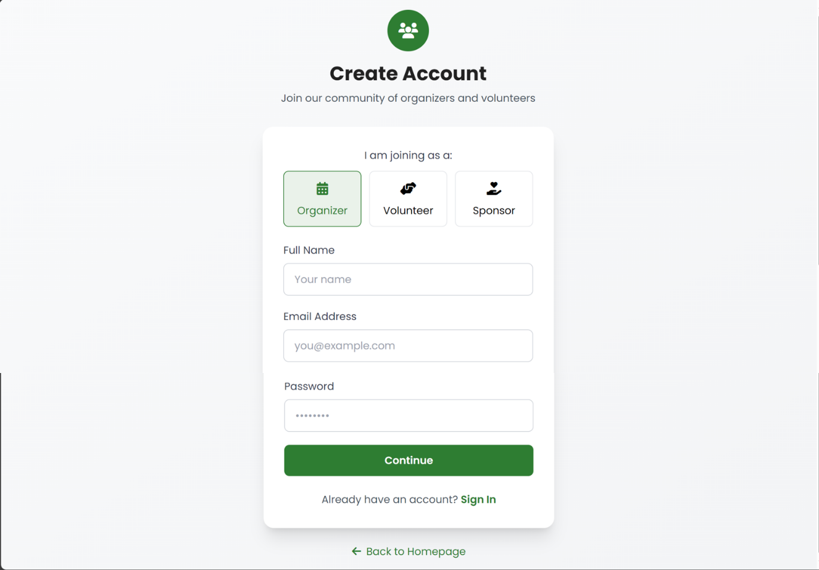
Organizer Dashboard
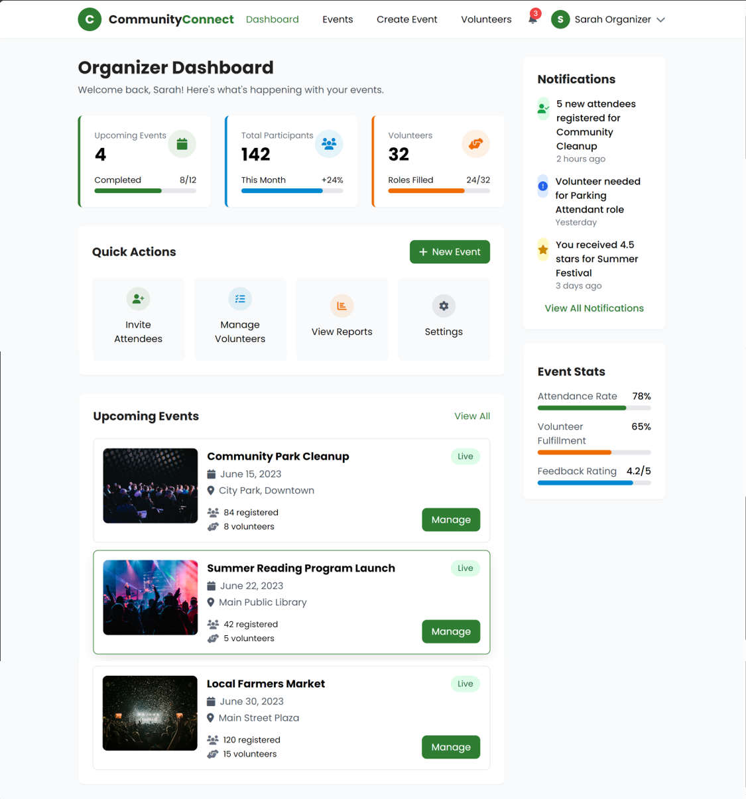

Event View and Management Screen
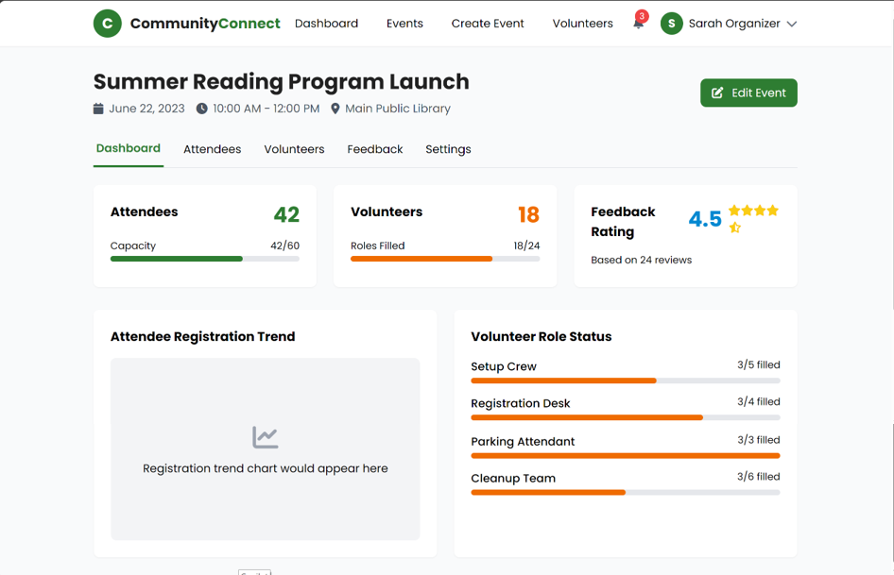

Events Catalog
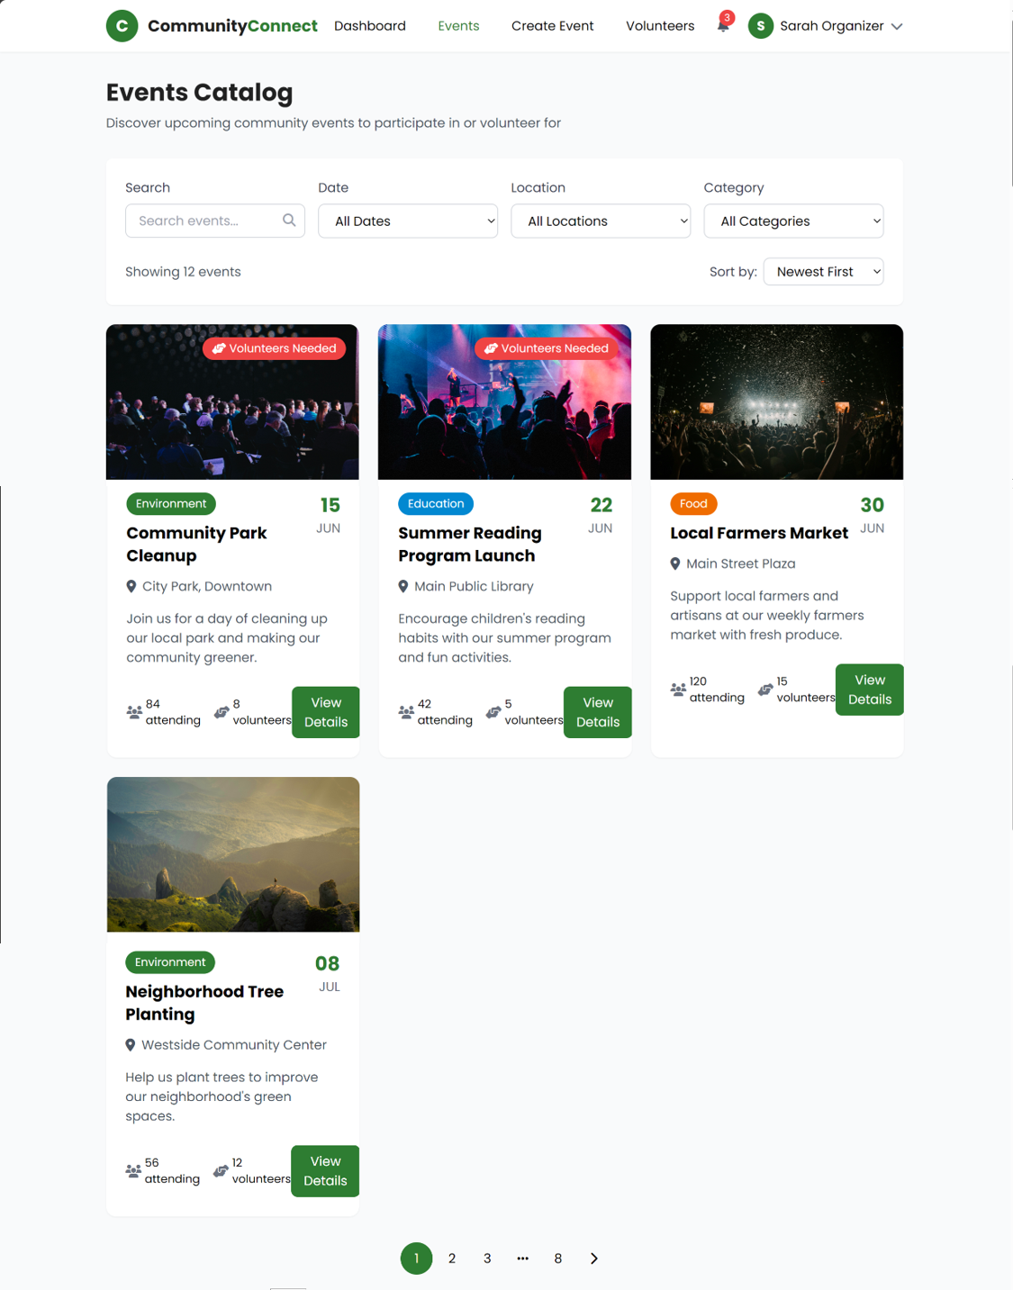
Event details and Booking
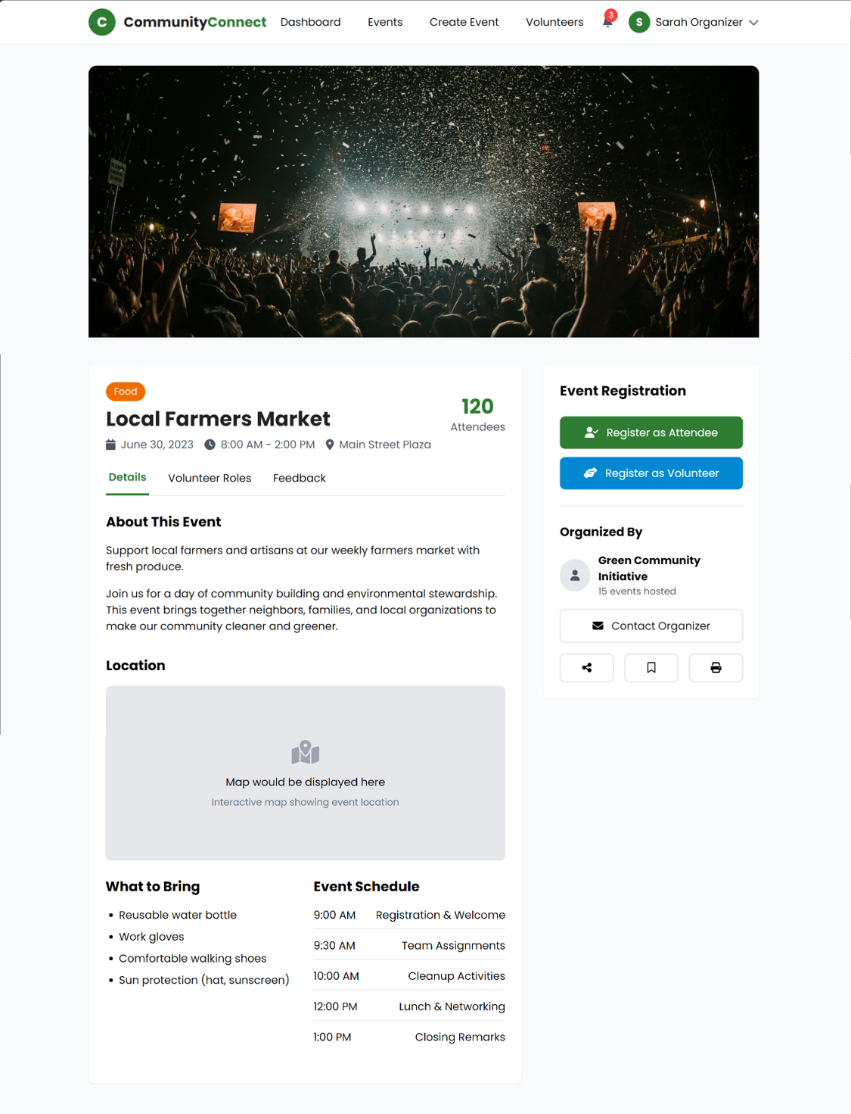

Password Reset
